Linux Programming: Assignment-5 :

- What is a shell in Linux OS? How many categories of shell is currently exists in Linux? Why bash shell is very popular in Linux distribution?

- A shell in Linux is a program that takes commands from the user and passes them to the operating system to perform tasks & it acts as an interface between the user and the system kernel.

- In Linux shells can be classified into 2 main types based on their interface :
- Command-Line Interface (CLI) Shells : These are text-based interfaces where users interact with the operating system by typing commands.
e.g.) Bourne shell(sh), Bourne again shell(BASH), Z shell(zsh), etc….

- Graphical User Interface (GUI) Shells: These provide a visual environment for interacting with the operating system using elements like windows, icons, and menus.
e.g.) GNOME shell, KDE plasma, MATE, etc…..
  - The Bash shell (Bourne Again Shell) is the most popular because:
- It’s the default shell in most Linux distributions
- It supports command history, scripting, and automation
- It is user-friendly and compatible with older shells

- What does the ls -Z command display?
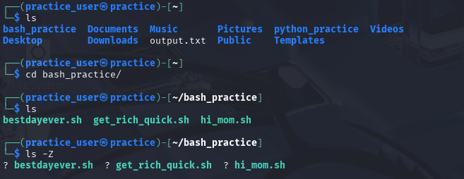
- Actually the “ls -Z” command is used to display the SELinux security context of files and directories.
- It shows extra security information like user, role, type, and level, in addition to normal Linux permissions.
- But on my system like DEBIAN this SELinux is not enabled by default thus it is showing “?” sign instead of the context.
- This command is mostly used on Red Hat, Fedora, or CentOS systems where SELinux is active.

- Write a command to list all hidden files in the current directory.

- “ls -a” this command is used to list all the files incuding the hidden files in the current directory.
- Since here we have no hidden files, we see nothing .
- Whereas,
“.” this is current directory
“..” this is parent directory
NOTE : These are not hidden files , hidden files would be something like “.hidden”.
- Explain the difference between hard links and soft links (symbolic links) in Linux.
- A hard link is like another name for the same file and points directly to the file’s inode.
NOTE: ("inode” is a data structure that stores all the info about the file except it’s name. )
- If the original file is deleted, the hard link still works.
- A soft link (symbolic link) is like a shortcut to the file’s path.
- If the original file is deleted, the soft link stops working.
- Hard links cannot link directories and usually cannot cross different file systems.
- Soft links can point to directories and files across different file systems. e.g.)
Hard link: “ln file1.txt file1_hardlink.txt”
Soft link: “ln -s file1.txt file1_softlink.txt”

- A file has permissions -rwxr-x--x. Explain who can read, write, and execute it.
- “-” shows that it’s a regular file.
- “rwx” means that owner can read,write and execute the file.
- “r-x” means that the group can read and ececute but it cannot write.
- “--x” this means that others can only execute the file and they can’t read or write.

- Write the command to change the group ownership of a file data.txt to group staff.
- chgrp staff data.txt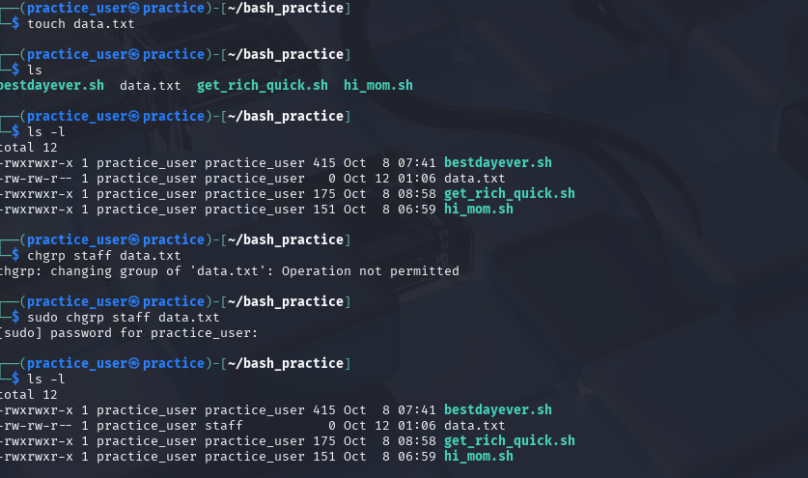

- Why is it dangerous to give 777 permissions to a file? Explain with an example.
- Actually the permission output that we see like “-rwx-r-rw-” is just the output when we give input we have to give it in the numerical form on the basis of (r=4, w=2, x=1).
- So when we give 7 permission that literally means we are giving 4+2+1=7 (i.e. rwx) permission .
- Similarly when we give 777 permission we give rwx permission to owner, group & others.
- Basically, anyone can modify, delete, or run the file, which is very risky.
- EXAMPLE : someone could add “rm -rf /” to delete all files, and now anyone running it will accidentally wipe the system.

- What is the difference between apropos (i.e., man -k) and whatis (i.e., man -f)?
- apropos (or man -k) searches for keywords in the manual page descriptions.
It’s useful when you don’t know the exact command name but know what it does.

e.g.) apropos copy or man -k copy
#Lists all commands related to “copy”
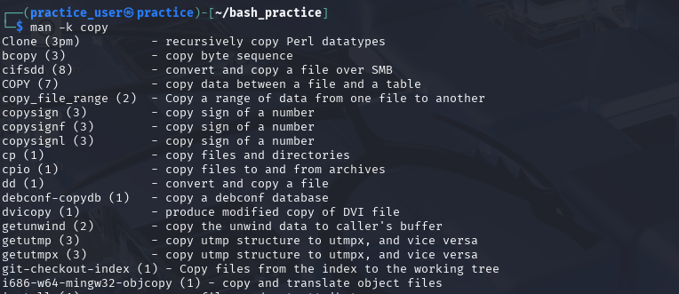

- man -f is the same as whatis. It gives a short description of a specific command.

e.g.) whatis cp or man -f cp
#Output: cp (1) – copy files and directories


- Write a command to redirect the error output of a command to a file named error.log.
- “command 2> error.log”
e.g.) ls /nonexistent 2> error.log #redirects error to a file.

- NOTE :
> → redirects standard output (stdout) to a file.
2> → redirects standard error (stderr) to a file.
>> → appends output to a file instead of overwriting.

- How can you use the tee command to append output to a file instead of overwriting it?

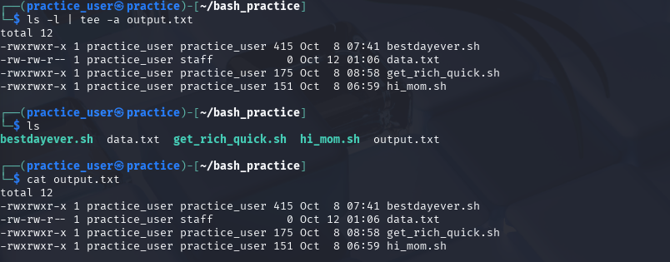
- NOTE: tee is always used with “-a” flag because tee by default overwrites the contents present in the file so, “a” flag is used so that tee would append on the file and not overwrite it.

